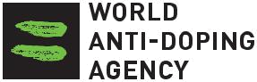
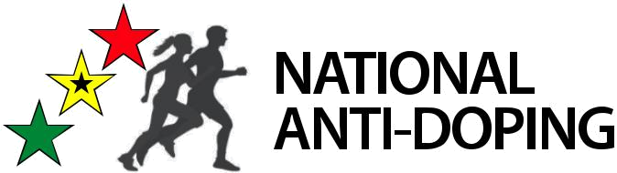
TRUE PLAY

16TH MARCH, 2023

RESULTS MANAGEMENT ARRANGEMENTS FOR AFRICA ZONE VI RADO MEMBER COUNTRIES
The Ghana Anti-Doping Committee presents its compliments.
We wish to inform you that the Continental Results Management Panel (CRMP) Africa has now completed the administrative and training requirements to start hearing cases. The panel has adopted the attached Procedural Rules, which explain in details the panel’s composition and modus operandi. Currently, the CRMP Africa has 12 members from nine different countries of which Ghana is part.
In view of the above, Ghana has adopted the African Region decision to use the CRMP as a first instance hearing panel.
Further to this, the Ghana Olympic Committee (GOC) in compliance with the World Anti-Doping Code and the International Standard for Results Management, and in line with Article 8.1.1.1 of its Anti-Doping Rules, has appointed the Continental Results Management Panel (CRMP) Africa to adjudicate matters pursuant to the Ghana Olympic Committee’s Anti-Doping rules and thus ensure the right to a fair hearing by an operationally independent panel for first instance hearings.
Also, provision should be made on the GOC website for Anti-Doping contents which would feature the World Anti-Doping Code, the Ghana Anti-Doping Rule, the Therapeutic Exemption Form (TUE) and a column for updates on educational programs organized by the Anti-Doping Office.
As you may recall, the National Antidoping committee (Ghana) had earlier in a memo reminded the GOC of the need to make these details available on the GOC website. This is a recommendation from WADA and failure to update the website will lead to non-compliance and suspension from international events. The Africa Antidoping office hence demand of an immediate update within 7 days.
Counting on your good office to avert any embarrassment to the country.

Please find attached, copies of the underlisted;
- Composition of the CRMP
- Continental Results Management Panel procedural rules
- International Result management Panel.

HON. DR. NANA AYEW AFRIYE
CHAIRMAN, GHANA ANTI-DOPING COMM.

THE PRESIDENT
GHANA OLYMPIC COMMITTEE
ACCRA, GHANA

Cc: Hon. Minister, Min. of Youth & Sports

The Director-General, National Sports Auth.

